

End of Day Summary – 8/21/2025

Intraday News • August 21, 2025

Edited by Kristen Radosh & Kylie Leverenz
US Treasuries
- Treasury yields retreated from session highs (led by the long-end) after a strong 30y TIPS auction
- Thursday's range for UST 10y: 4.29% - 4.345%, closing at 4.33%
- Thursday's range for UST 30y: 4.89% - 4.94%, closing at 4.92%
- Fed's Bullard: Backs 100 Basis Points of 2025 Cuts
- Fed's Bostic: Still Sees one 2025 Rate Cut, But Monitoring Labor
- Fed's Schmid: Says Modestly Restrictive Policy is Still Appropriate
Bloomberg: Pension Funds Missing Tech Rally Turn to Completion Portfolios
Bloomberg: Mutual Funds Bleed Another $432 Billion as ETF Conversions Grow

Conference Call Replay:
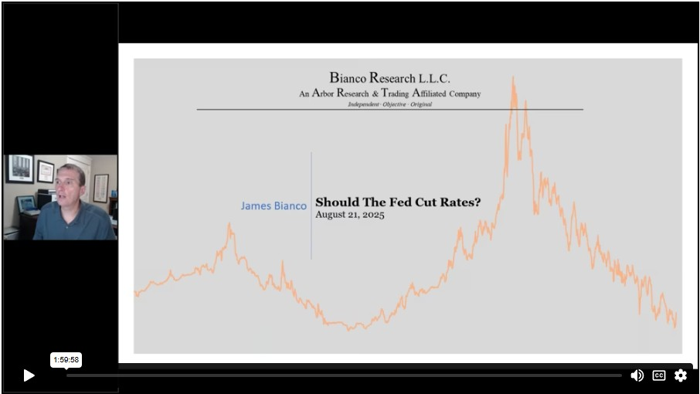
Click here for the Replay
Upcoming US Treasury Supply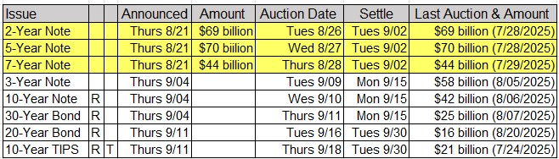
Jim Bianco's Commentary on Today's 30y TIPS Auction (Reopening):
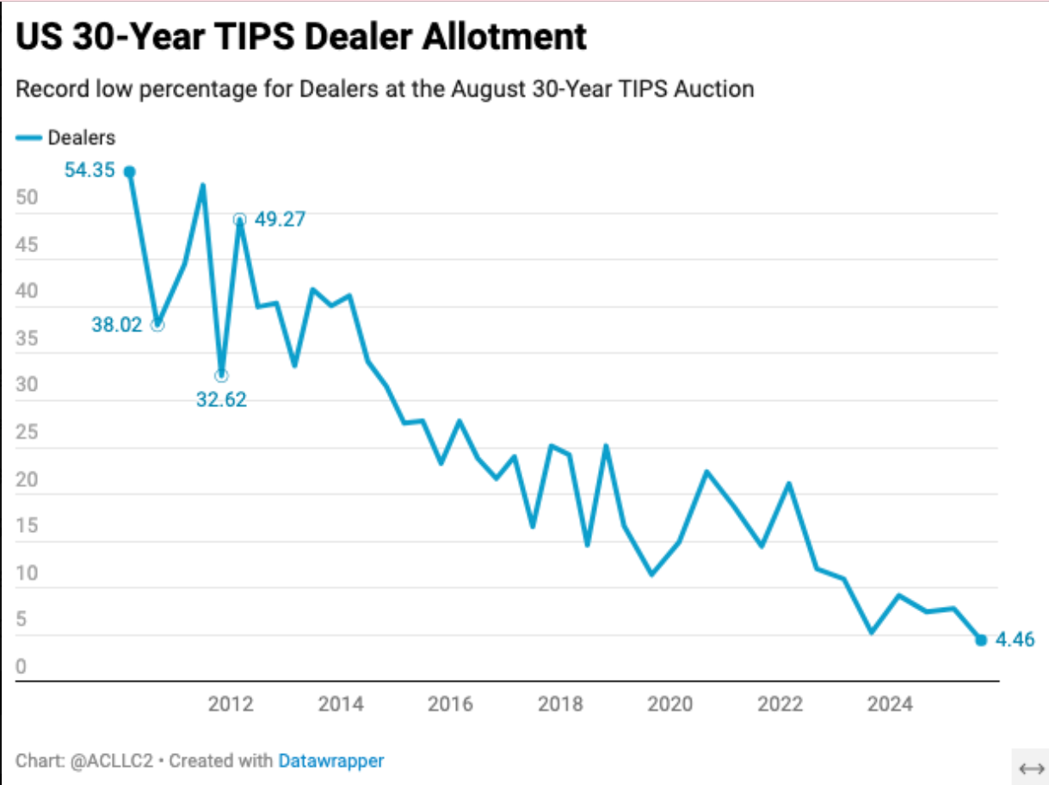
Stellar auction! Grade = A
The 30-year TIPS traded through (negative tail) by 2.3bps. Bid-2-cover chart (above), but this is back to 2010. It was the highest in 8 years, and the second-highest in 13 years.
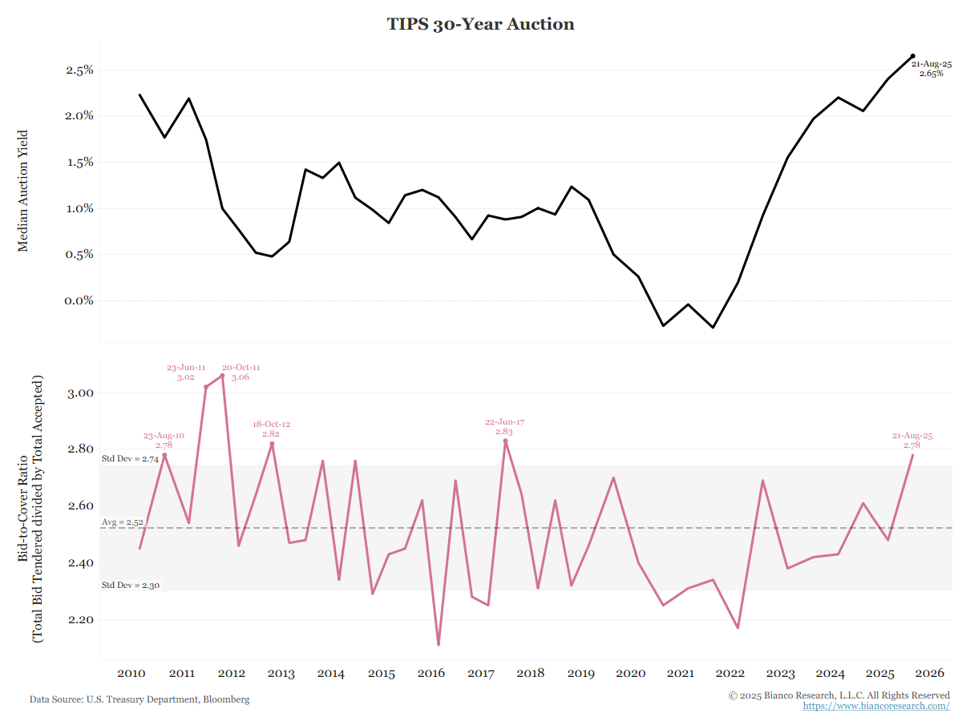

Tentative Schedule of Treasury Buyback Operations
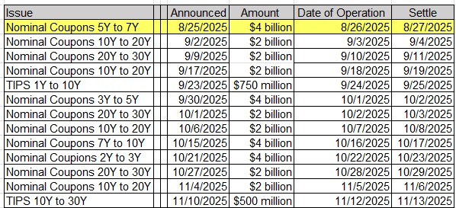

Intraday Commentary from Jim Bianco:
Weak-Kneed About Powell's Speech Tomorrow? (That he will push back about a rate cut)
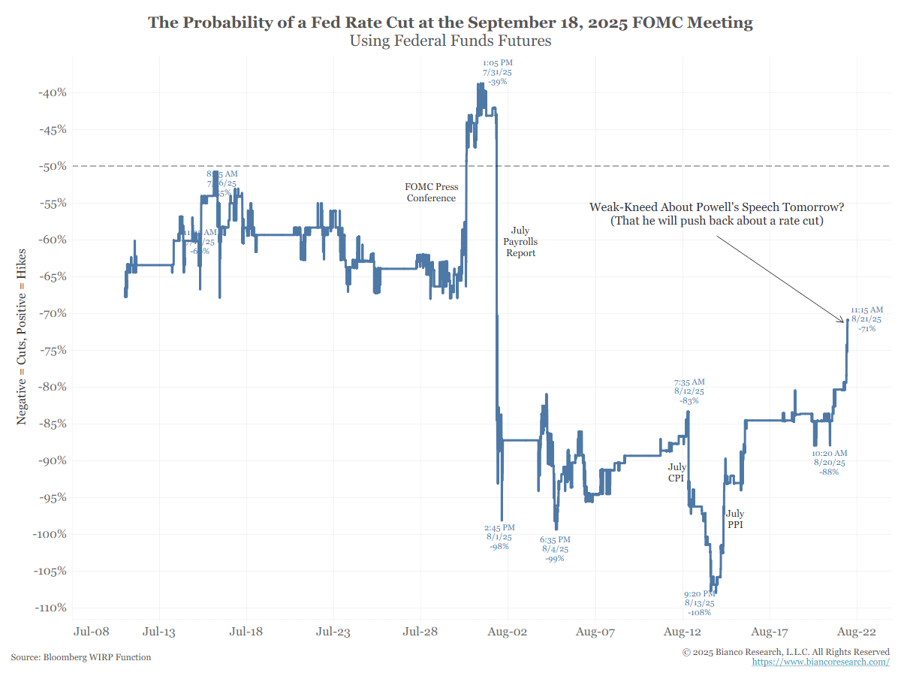
Note that the probability of a rate cut is still 70%, so it is still greater than 50%. It was 88% yesterday.

In Other News
CNBC: How billionaire family offices bet on stocks during tariff turmoil
Supply Chain Brain: Walmart Raises Sales Forecast for 2025
Axios: Unauthorized immigrant population hit record 14M in 2023; Pew analysis
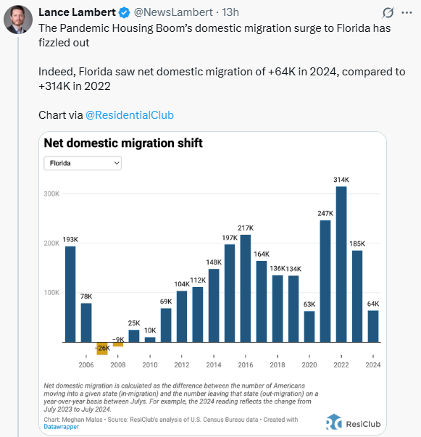

Upcoming Economic Releases & Fed Speak
- 8/22/2025 at 09:00am EST: Fed's Collins Appears on Bloomberg TV
- 8/22/2025 at 10:00am EST: Fed's Powell Speaks on Economic Outlook at Jackson Hole
- 8/25/2025 at 08:30am EST: Chicago Fed Nat Activity Index
- 8/25/2025 at 10:00am EST: New Home Sales / New Home Sales MoM
- 8/25/2025 at 10:30am EST: Dallas Fed Manf. Activity
- 8/25/2025: Building Permits / Building Permits MoM
- 8/25/2025 at 03:15pm EST: Fed's Logan Speaks at Bank of Mexico Centennial Conference
- 8/25/2025 at 07:15pm EST: Fed's Williams Gives Keynote Remarks
- 8/26/2025 at 00:01am EST: Fed's Barkin Repeats Remarks on the Economy
- 8/26/2025 at 08:30am EST: Philadelphia Fed Non-Manufacturing Activity
- 8/26/2025 at 08:30am EST: Durable Good Orders / Durables Ex Transportation
- 8/26/2025 at 08:30am EST: Cap Good Orders Nondef Ex Air / Cap Good Ship Nondef Ex Air
- 8/26/2025 at 09:00am EST: FHFA House Price Index Mom
- 8/26/2025 at 09:00am EST: House Price Purchase Index QoQ
- 8/26/2025 at 09:00am EST: S&P CoreLogic CS 20 CityMoM SA / YoY/NSA / US HPI YoY NSA
- 8/26/2025 at 10:00am EST: Richmond Fed. Manufact. Index / Richmond Fed Business Conditions
- 8/26/2025 at 10:00am EST: Conf. Board Consumer Confidence / Present Situation / Expectations
- 8/26/2025 at 10:30am EST: Dallas Fed Services Activity
- 8/27/2025 at 00:01am EST: Fed's Barkin Repeats Remarks on the Economy
- 8/27/2025 at 07:00am EST: MBA Mortgage Applications
- 8/27/2025 at 06:00pm EST: Fed's Waller Speaks on Monetary Policy
- 8/28/2025 at 08:30am EST: GDP Annualized QoQ
- 8/28/2025 at 08:30am EST: Personal Consumption
- 8/28/2025 at 08:30am EST: GDP Price Index / Core PCE price Index QoQ
- 8/28/2025 at 08:30am EST: Initial Jobless Claims / Initial Claims 4-Wk Moving Avg
- 8/28/2025 at 08:30am EST: Continuing Claims
- 8/28/2025 at 10:00am EST: Pending Home Sales MoM / Pending Homes Sales NSA YoY
- 8/28/2025 at 11:00am EST: Kansas City Fed Manf. Activity

