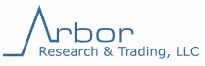

End of Day Summary – 10/03/2025

Intraday News • October 03, 2025

Edited by Kristen Radosh & Kylie Leverenz
US Treasuries
- Friday's range for UST 10y: 4.075% - 4.115%, closing at 4.115%
- Weekly range for UST 10y: 4.075% - 4.165%
- Friday's range for UST 30y: 4.67% - 4.71%, closing at 4.71%
- Weekly range for UST 30y: 4.67% - 4.75%
- Fed's Goolsbee: says Fed in Sticky Spot as Jobs, Price Goals in Tension
- Fed's Miran: says He'd Adjust Inflation View If Rents Turn Higher
- Fed's Jefferson: Again Cautions on Risks to Inflation, Jobs Goals
- Fed's Logan: Signals Inflation Is Top Issue, Urges Rate Caution

TIPS by Maturity (data through 9/24/25)
Week over Week Changes by Maturity
- < 2 years: $19.0 Bn on 9/17/25 to $19.1 Bn on 9/24/25 = $0.1 Bn
- 2 – 6 years: $705 Mn on 9/17/25 to $412 Mn on 9/24/25 = ($293 Mn)
- 6 – 11 years: $3.8 Bn on 9/17/25 to $5.4 Bn on 9/24/25 = $1.6Bn
  - > 11 years: $749 Mn on 9/17/25 to $738 Mn on 9/24/25 = ($11 Mn)
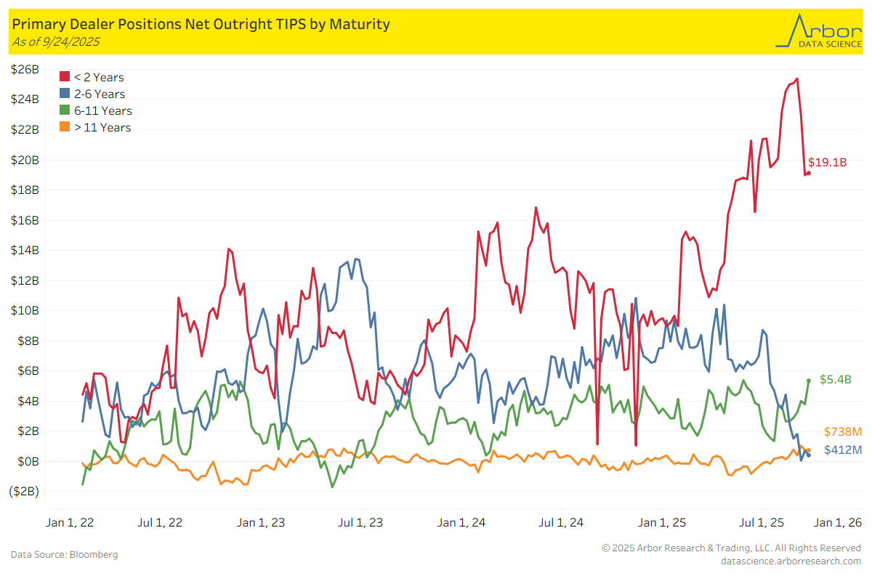

In the News
Bloomberg: DoubleLine Says Shutdown Adds Fuel to Popular Treasuries Trade
yahoo!finance: BlackRock Nears $40B Data Center Deal in Bet on AI
OilPatch: Fire Erupts at Chevron Refinery in California
InsuranceBusinessMag: California's FAIR Plan files for largest rate hike in seven years
CarDealershipGuy: GM, Ford, Hyundai, Toyota Ride EV Credit Wave to Record U.S. Sales in Q3

Upcoming US Treasury Supply
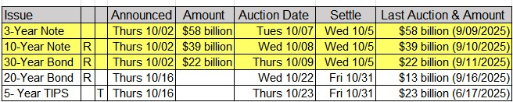
Tentative Schedule of Treasury Buyback Operations
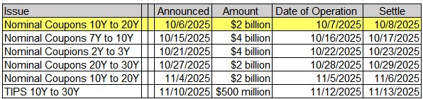
Upcoming Economic Releases & Fed Speak
- 10/07/2025 at 08:30am EST: Trade Balance
- 10/07/2025 at 08:30am EST: Exports MoM / Imports MoM
- 10/07/2025 at 10:00am EST: Fed's Bostic Speaks at Fisk University in Nashville
- 10/07/2025 at 10:30am EST: Fed's Miran in Fireside Chat
- 10/07/2025 at 11:00am EST: NY Fed 1-Yr Inflation Expectations
- 10/07/2025 at 11:00am EST: Fed's Kashkari Speaks at Star Tribune Summit
- 10/07/2025 at 03:00pm EST: Consumer Credit
- 10/08/2025 at 07:00am EST: MBA Mortgage Applications
- 10/08/2025 at 09:20am EST: Fed's Musalem Gives Welcoming Remarks
- 10/08/2025 at 09:30am EST: Fed's Barr Keynote at Community Banking Research Conference
- 10/08/2025 at 02:00pm EST: FOMC Meeting Minutes
- 10/08/2025 at 03:15pm EST: Fed's Kashkari Speaks at Center for Indian Country Development
- 10/08/2025 at 06:30pm EST: Fed's Kashkari Hosts Fireside Chat with Senator Tina Smith
- 10/09/2025 at 08:30am EST: Initial Jobless Claims / Initial Claims 4-Wk Moving Avg /
- 10/09/2025 at 08:30am EST: Continuing Claims
- 10/09/2025 at 10:00am EST: Wholesale Trade Sales MoM / Wholesale Inventories MoM
- 10/09/2025 at 01:00pm EST: Fed's Kashkari and Bar Speak in Conversation
- 10/09/2025 at 07:40pm EST: Fed's Daly at the Silicon Valley Directors Exchange
- 10/10/2025 at 09:45am EST: Fed's Goolsbee Gives Opening Remarks
- 10/10/2025 at 10:00am EST: U. of Mich. Sentiment / Current Conditions / Expectations
- 10/10/2025 at 10:00am EST: U. of Mich. 1 Yr Inflation / 5 - 10 Yr Inflation
- 10/10/2025 at 09:45am EST: Fed's Goolsbee Gives Opening Remarks
- 10/10/2025 at 02:00pm EST: Federal Budge Balance
- 10/10/2025 at 02:00pm EST: Fed's Musalem Speaking at Springfield Area Chamber of Commerce

