

End of Day Summary – 4/14/2026

Intraday News • April 14, 2026

Edited by Kristen Radosh & Kylie Leverenz
US Treasuries
10s closed on Tuesday at 4.25
- 1st daily resistance is 4.22/4.23 83% to hold
- 2nd daily resistance is 4.20/4.21 90% to hold
- 1st weekly resistance at 4.215/4.25 75% to hold

- 1st monthly resistance at 4.095/4.125 67% to hold
- 1st daily support is 4.285/4.295 80% to hold
- 2nd daily support is 4.32/4.33
- 1st weekly support at 4.38/4.405

- 1st monthly support at 4.465/4.495 80% to hold

Bloomberg: Warsh Fed Chair Hearing Set for Next Week, Tim Scott Says

Intraday Commentary From Jim Bianco

The markets have "deal on" fever. Here is a one-day tick chart of Brent Crude.

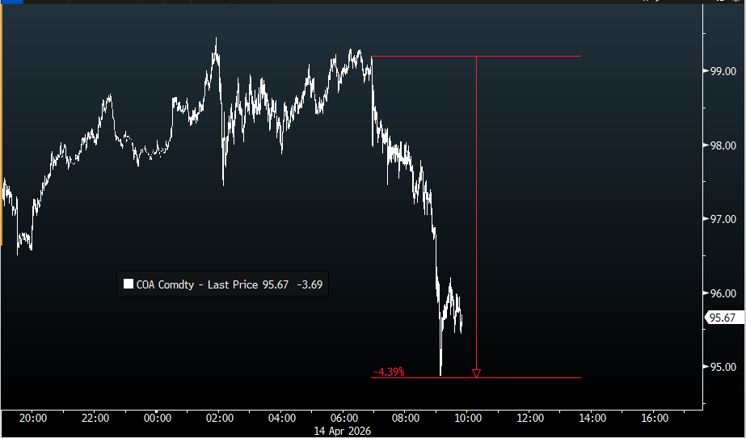
The "deal on" hype machine is now in high gear.
*TRUMP SAYS IRAN TALKS COULD HAPPEN OVER NEXT TWO DAYS: NYP

If a deal happens that opens the strait, and everything starts moving, these markets are correctly priced.

No deal ... things could get "interesting."

The S&P 500 all-time closing high was January 27, 2026, at 6,978.60.
AS I write this S&P 500 is 6,955, less than 14 points away now.
The last six months of closing the S&P 500. The green annotation shows it is up ~10% is 10 trading days.
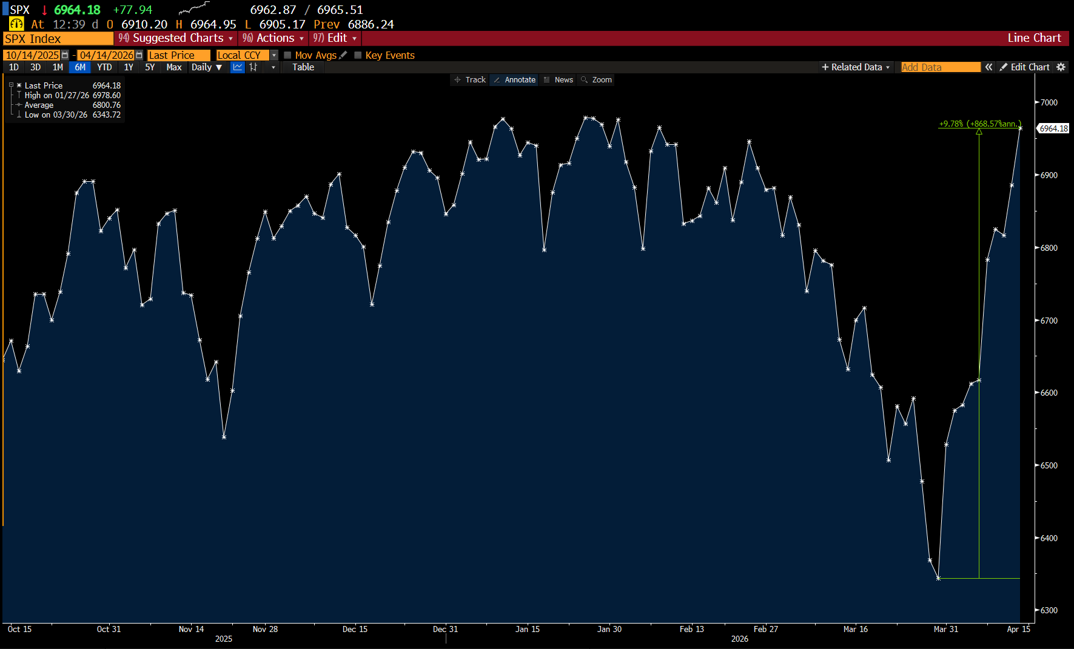

Last night I posted this chart of TLT's volume and noted it only traded 12.720M shares, the lowest daily volume since January 2023 (and this INCLUDES holidays). I suggested this was a signal of waning interest in the bond market right now.

With 1 hour left in today's trading, TLT has traded only 9.2M shares. Unless TLT has a run in this hour, another new three low might be in the offing.
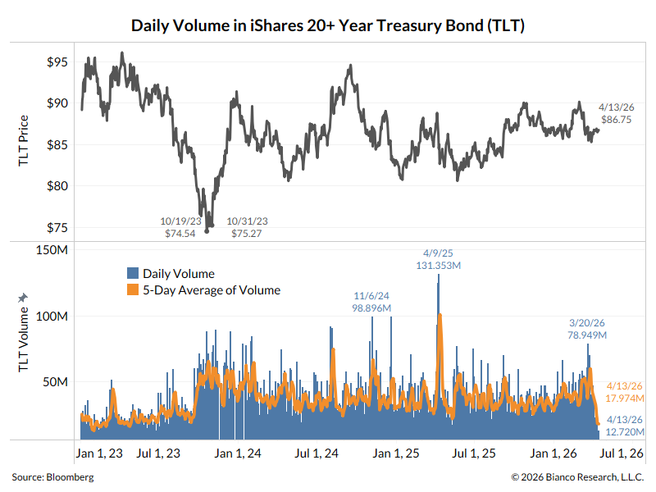

In the News
SuccessfulFarming: China March Soybean Imports Rise 15% y/y, Lag Expectations Amid Brazil Checks
PRNewswire: CARFAX: Used Car Prices Spike after Hitting 12-Month Low
Bloomberg: Struggling American Truckers Now Have Another Thing to Worry About
Naples Daily News: Wildfires burning across Florida drought continues. How bad is it?

Upcoming US Treasury Supply
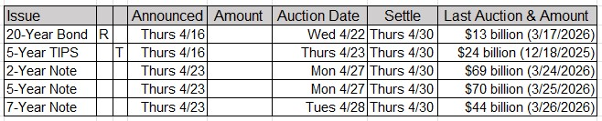

Upcoming Economic Releases & Fed Speak
- 4/15/2026 at 07:00am EST: MBA Mortgage Applications
- 4/15/2026 at 08:30am EST: Fed's Barr in Moderated Discussion
- 4/15/2026 at 08:30am EST: Empire Manufacturing
- 4/15/2026 at 08:30am EST: Import Price Index MoM / YoY and Import Price Index ex Petroleum
- 4/15/2026 at 08:30am EST: Export Price Index MoM / YoY
- 4/15/2026 at 10:00am EST: NAHB Housing Market Index
- 4/15/2026 at 01:45pm EST: Fed's Bowman Speaks at IIF Forum
- 4/15/2026 at 02:00pm EST: Fed Releases Beige Book
- 4/15/2026 at 04:00pm EST: Total Net TIC Flows
- 4/15/2026 - 4/23/2026: Leading Index
- 4/16/2026 at 08:30am EST: New York Fed Services Business Activity
- 4/16/2026 at 08:30am EST: Initial Jobless Claims / Initial Claims 4-Wk Moving Avg
- 4/16/2026 at 08:30am EST: Continuing Claims
- 4/16/2026 at 08:30am EST: Philadelphia Fed Business Outlook
- 4/16/2026 at 08:35am EST: Fed's Williams Gives Keynote Remarks
- 4/16/2026 at 09:15am EST: Industrial Production MoM / Manufacturing (SIC) Production
- 4/16/2026 at 09:15am EST: Capacity Utilization
- 4/16/2026 at 10:35am EST: Fed's Miran Speaks in Moderated Discussion
- 4/16/2026 at 11:30am EST: Fed's Daly Speaks in Moderated Conversation
- 4/17/2026 at 12:15pm EST: Fed's Barkin Repeats Economic Outlook Speech
- 4/17/2026 at 02:00pm EST: Fed's Waller Speaks on Economic Outlook
- 4/18/2026 - 4/30/2026: Fed's External Communications Blackout
- 4/21/2026 at 08:15am EST: ADP Weekly Employment Change
- 4/21/2026 at 08:30am EST: Philadelphia Fed Non-Manufacturing Activity
- 4/21/2026 at 08:30am EST: Retail Sales Advance MoM / Ex Auto MoM / Ex Auto and Gas
- 4/21/2026 at 08:30am EST: Control Group
- 4/21/2026 at 10:00am EST: Business Inventories
- 4/21/2026 at 10:00am EST: Pending Home Sales MoM / NSA YoY

